**Amazon Sales Data Analysis**

**Author:** Kushal

**Data Analyst**

### ****Abstract****

Amazon sales datasets provide valuable insights into e-commerce trends, customer purchasing behavior, and product performance. This dataset contains information on various aspects of sales, including product categories, order volume, revenue, customer demographics, and payment methods. The objective of this project is to perform Exploratory Data Analysis (EDA) to uncover key trends and patterns in online sales.

### ****1. Problem Statement****

The demand for e-commerce products is influenced by multiple factors such as pricing, seasonal trends, customer reviews, and discounts. This analysis aims to identify key elements affecting Amazon sales and provide insights that can help optimize sales strategies.

### ****2. Introduction****

The Amazon sales dataset includes numerical, categorical, and temporal data. It contains columns such as product name, category, price, sales volume, discount percentage, customer ratings, and order dates. Our objective is to analyze product sales trends, revenue patterns, and customer preferences to enhance sales performance.

### ****3. Steps Involved****

#### ****Data Wrangling****

After loading the data set, various pre-processing steps were performed to ensure data accuracy and reliability:

* **Loading Data:** The data set was loaded from CSV files using Pandas.
* **Handling Missing Values:** Missing values in categorical columns were replaced with the mode, while numerical columns were filled with the median.
* **Duplicate Removal:** Duplicate records were identified and removed to maintain data integrity.
* **Data Type Conversion:** Necessary conversions were made, such as transforming date formats and ensuring correct numerical representations.

#### ****Exploratory Data Analysis (EDA)****

Several analytical techniques were used to extract insights:

1. **Sales Trends Analysis:** Understanding seasonal sales fluctuations and best-selling periods.
2. **Revenue Insights:** Analyzing total revenue and profit margins across different product categories.
3. **Customer Behavior Analysis:** Evaluating the impact of customer ratings and reviews on sales.
4. **Discount and Pricing Impact:** Studying how discounts affect sales volume and revenue generation.
5. **Payment Method Trends:** Analyzing the preferred payment options used by customers.

#### ****Visualizations Used:****

Data visualizations were created using Matplotlib and Seaborn to highlight key insights:

* **Order Status Distribution:** The majority of orders were delivered successfully, while a smaller percentage was canceled or returned.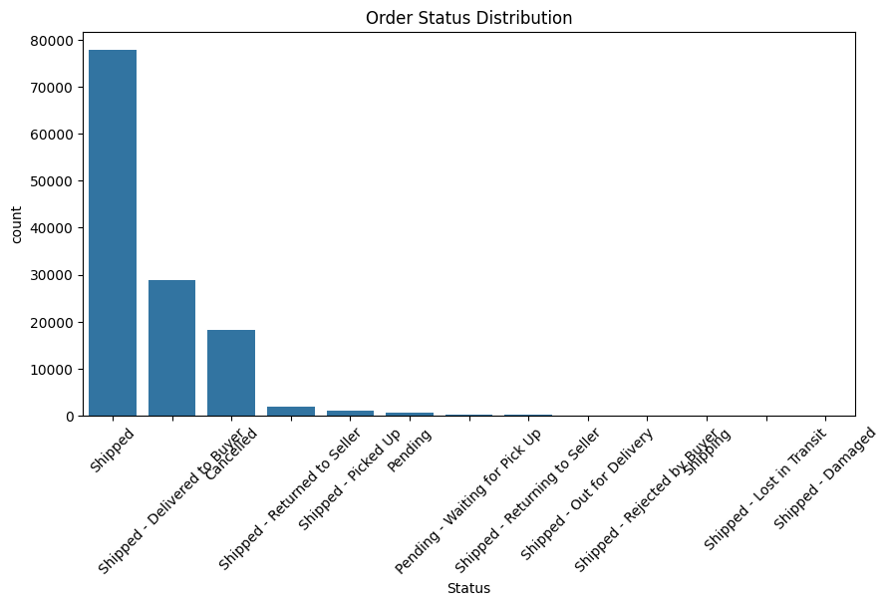
* **Order Amount Distribution:** The order amount varies significantly, with a few high-value purchases contributing to major revenue.

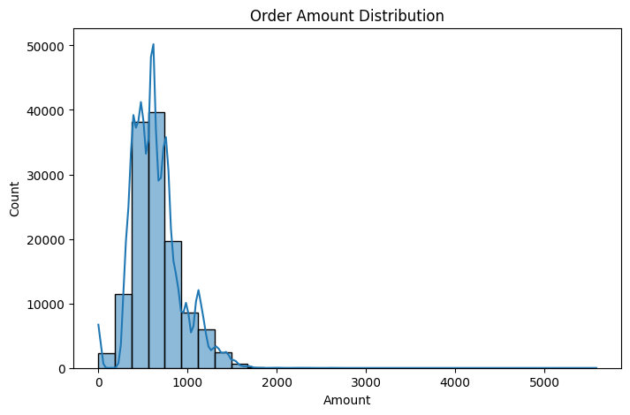

* **Fulfillment Method Distribution:** Most orders were fulfilled through Amazon’s in-house logistics, while third-party fulfillment accounted for a smaller share.

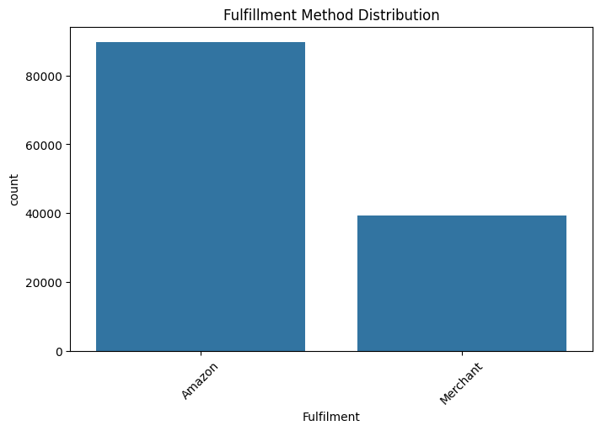

* **Sales Channel Distribution:** The majority of purchases came through online marketplaces, with fewer orders via direct sellers.

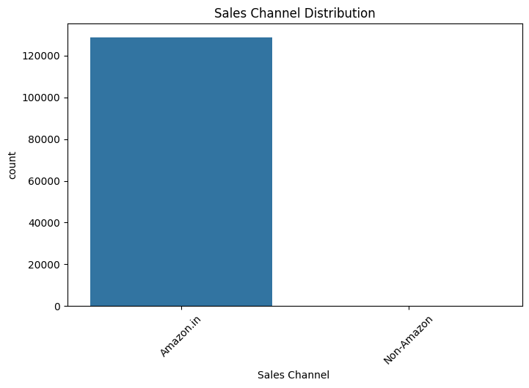

* **Top 10 Ordered SKUs:** A few products dominated the sales volume, indicating strong demand for specific items.

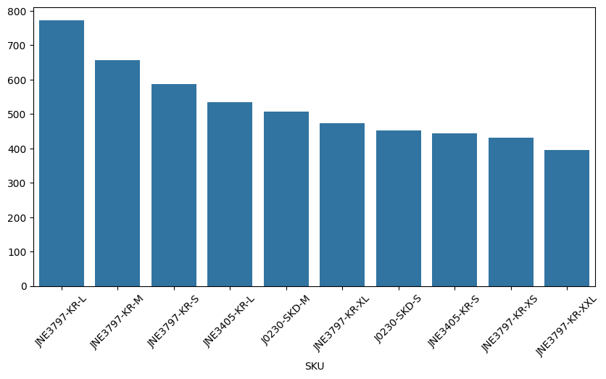

### ****4. Key Insights****

* **Peak Sales Periods:** Sales spikes were observed during festive seasons and discount campaigns.
* **Revenue Distribution:** High-priced electronics and fashion products contributed the most to total revenue.
* **Customer Preferences:** Products with high ratings and positive reviews had higher sales volumes.
* **Impact of Discounts:** Discounts significantly influenced purchase behavior, increasing sales but reducing profit margins.
* **Popular Payment Methods:** Credit/Debit card transactions dominated, with digital wallets gaining popularity.
* **Fulfillment Insights:** Amazon’s in-house fulfillment handled most orders efficiently, reducing delivery times.
* **Sales Channels:** Online marketplaces remain the primary sales channel, while direct sellers contribute to a niche market.

### ****5. Conclusion****

* **Seasonal and Promotional Sales Drive Revenue:** Companies should focus on seasonal promotions and sales events to maximize revenue.
* **Customer Reviews Influence Sales:** Encouraging customer reviews and ratings can improve product visibility and sales.
* **Optimal Pricing Strategies:** Businesses should balance discounts and pricing to maintain profitability while attracting customers.
* **Payment Trends:** Digital payment adoption is increasing, requiring businesses to support multiple payment options.
* **Efficient Fulfillment Methods:** Streamlining fulfillment processes can improve customer satisfaction and reduce order cancellations.

### ****6. References****

* Kaggle Datasets
* Pandas & Matplotlib Documentation
* E-commerce Data Analysis Tutorials from W3Schools, GeeksforGeeks